Introduction to Bibliometric Visualization

7/14/16

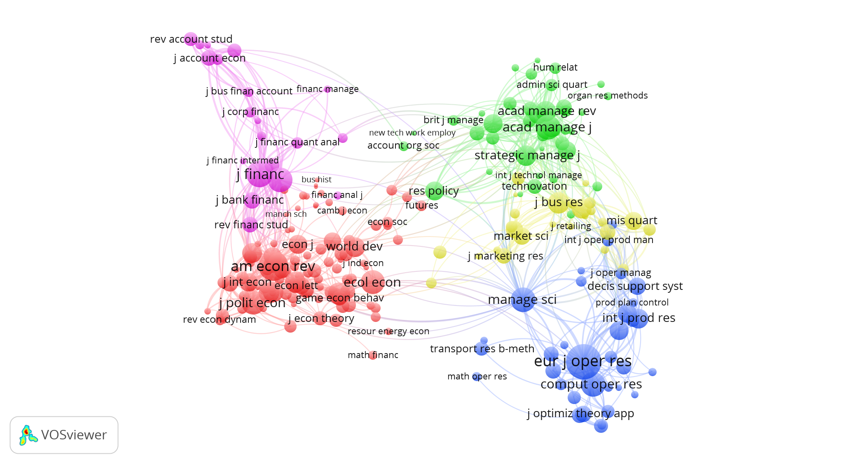

Nodes & edges have characteristics or attributes that tell you more about relationships.

Edge: shows the connection between the pair of nodes

Nodes: objects in the graph that are connected to one another.

**Three Basic Types of Publication Networks**:

1. Collaboration Networks: shows collaboration between authors, institutions, or locations in the production of work. The most common is the co-author network, where nodes represent authors.
2. Semantic Networks: analyzes the occurrence of certain words in a publication or a set of publications. The most common type is a co-occurrence network where nodes represent words and edges represent the *co-occurrence* of those words in the same publication.
3. Citation Networks: shows the relationship of publications based on their citations. Node size is determined on the number of citations each publication has received and edges are sized based on the strength of citation similarity.
   1. Direct citation: edges represent a direct citation from publication A to publication B (doesn’t tell you much in terms of actual structure of research)
   2. Bibliographic coupling: an edge connects two nodes if both publications have cited the same publication (shows likeness in citations)
   3. Co-citation network: the “forward” version of bibliographic coupling – an edge is drawn between two nodes if both publications are cited by a subsequent publication.

Create your own visualization in VOSviewer:

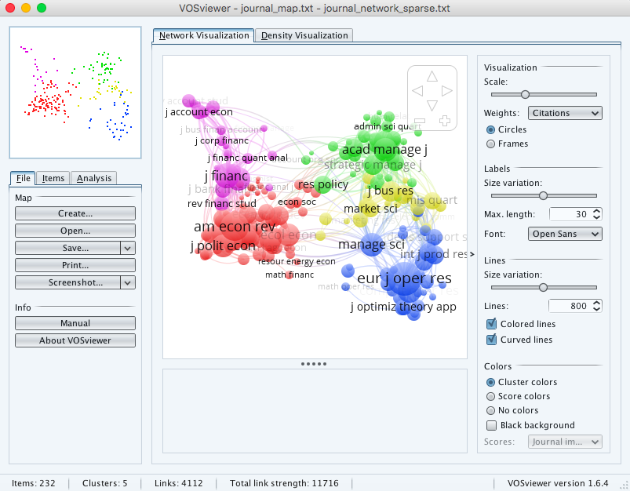

1. Under the File tab, select Create
2. Select the middle radio button: “Create a map based on bibliographic data”
3. Select the tab of file type you’ll be using (Web of Science, Scopus, PubMed, or RIS) and upload your file.
4. Once you’ve selected your file, click “next.”
5. Select your type of analysis and counting method. Mouse over the ? to learn more about each type.
6. Select your threshold – the lower your threshold, the higher the number of nodes you’ll have in your map. Select next to review the items that will make up your nodes.
7. Click Finish to view your map
8. Use the Options panel on the right hand side to manipulate and make changes to your map.

Downloading Files to use in VOSviewer:

Web of Science:

1. From the results page, select the “Save to EndNote online” dropdown.
2. Select “Save to Other File Formats”

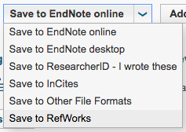

1. Select the number of records you would like downloaded (ex. 1-500)
2. Select Record Content: “Full Record and Cited References”
3. Select File format: Tab-delimited (Win or Mac)

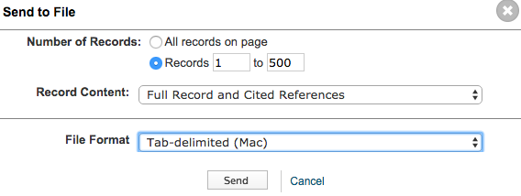

PubMed:

1. Select desired number of search results.
2. Select dropdown arrow in “Send to” menu
3. Choose Destination: File
4. Format: MEDLINE
5. Create File

